# Data Dictionary

## 1. Employee Table

* **Primary Key:** emp_id
* **Foreign Keys:** med_Key references Mediator(m_id), img_id references Image(img_id)
* **Attributes:**
  + emp_id (Primary Key)
  + username (Unique)
  + password
  + full_name
  + email (Unique)
  + phone_no
  + address
  + pincode
  + med_Key (Foreign Key)
  + skills
  + description
  + jobs_done (Default Value: 0)
  + experience
  + img_id (Foreign Key)
  + isEngaged

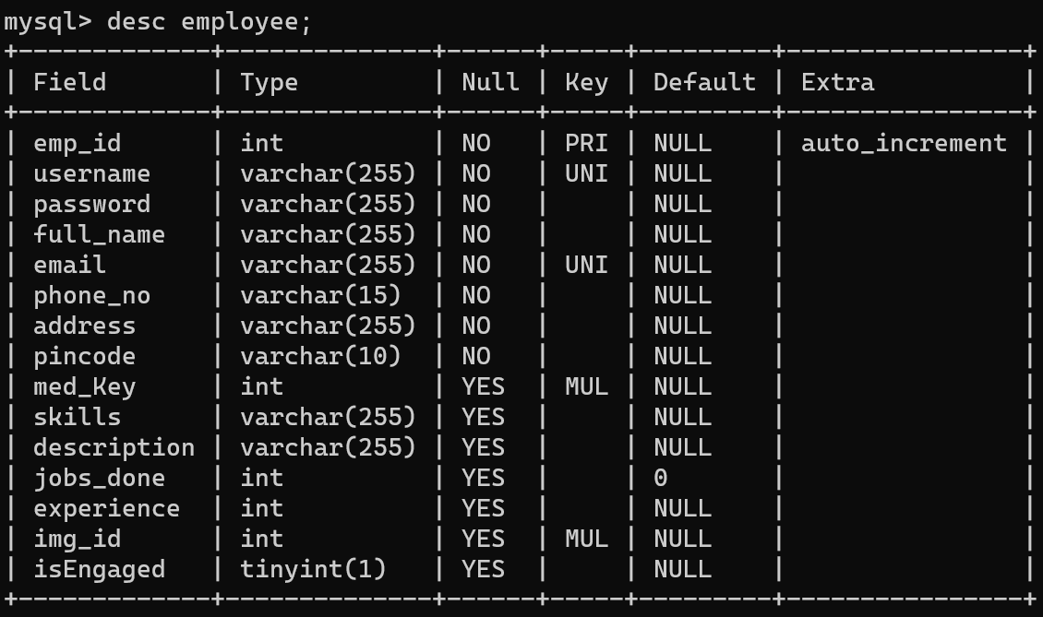

## 2. Mediator Table

* **Primary Key:** m_id
* **Foreign Key:** img_id references Image(img_id)
* **Attributes:**
  + m_id (Primary Key)
  + username (Unique)
  + password
  + full_name
  + email (Unique)
  + phone_no
  + address
  + img_id (Foreign Key)

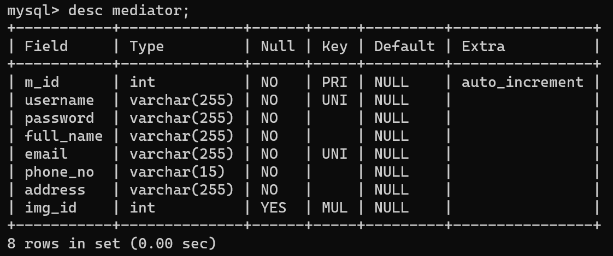

## 3. Customer Table

* **Primary Key:** cust_id
* **Foreign Key:** img_id references Image(img_id)
* **Attributes:**
  + cust_id (Primary Key)
  + username (Unique)
  + password
  + full_name
  + email (Unique)
  + phone_no
  + address
  + pincode
  + img_id (Foreign Key)

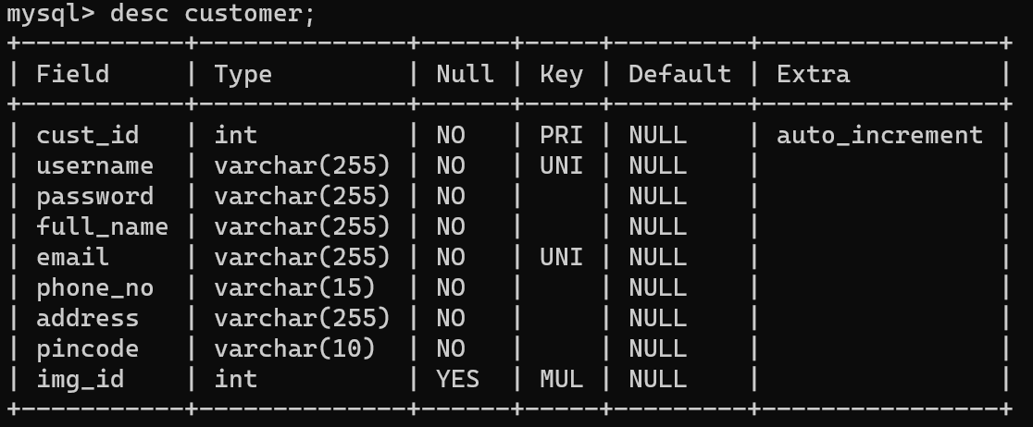

## 4. Service Request Table

* **Primary Key:** sr_id
* **Foreign Key:** cust_id references Customer(cust_id)
* **Attributes:**
  + sr_id (Primary Key)
  + cust_id (Foreign Key)
  + skills_req
  + pincode

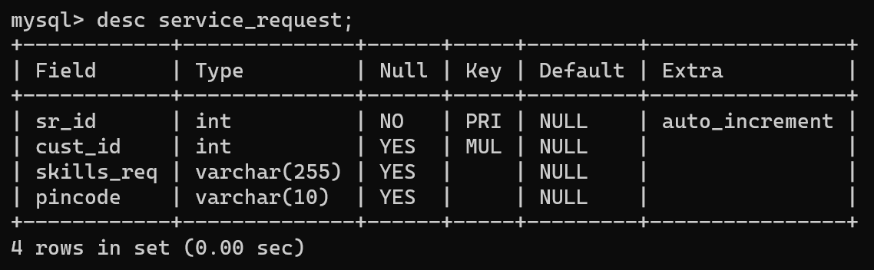

## 5. Image Table

* **Primary Key:** img_id
* **Attributes:**
  + img_id (Primary Key)
  + file_path
  + person_id (Unique)

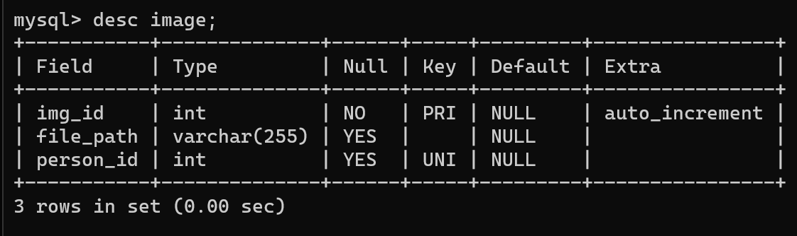

# Normalization Analysis

## 1. Employee Table

* **1st Normal Form (1NF):** Yes, all values are atomic.
* **2nd Normal Form (2NF):** Yes, no partial dependencies.
* **3rd Normal Form (3NF):** Yes, no transitive dependencies.

## 2. Mediator Table

* **1st Normal Form (1NF):** Yes, all values are atomic.
* **2nd Normal Form (2NF):** Yes, no partial dependencies.
* **3rd Normal Form (3NF):** Yes, no transitive dependencies.

## 3. Customer Table

* **1st Normal Form (1NF):** Yes, all values are atomic.
* **2nd Normal Form (2NF):** Yes, no partial dependencies.
* **3rd Normal Form (3NF):** Yes, no transitive dependencies.

## 4. Service Request Table

* **1st Normal Form (1NF):** Yes, all values are atomic.
* **2nd Normal Form (2NF):** Yes, no partial dependencies.
* **3rd Normal Form (3NF):** Yes, no transitive dependencies.

## 5. Image Table

* **1st Normal Form (1NF):** Yes, all values are atomic.
* **2nd Normal Form (2NF):** Yes, no partial dependencies.
* **3rd Normal Form (3NF):** Yes, no transitive dependencies.